SCREENSHOTS OF SQL FILES
SCREENSHOT 1:DATA EXPLORATION
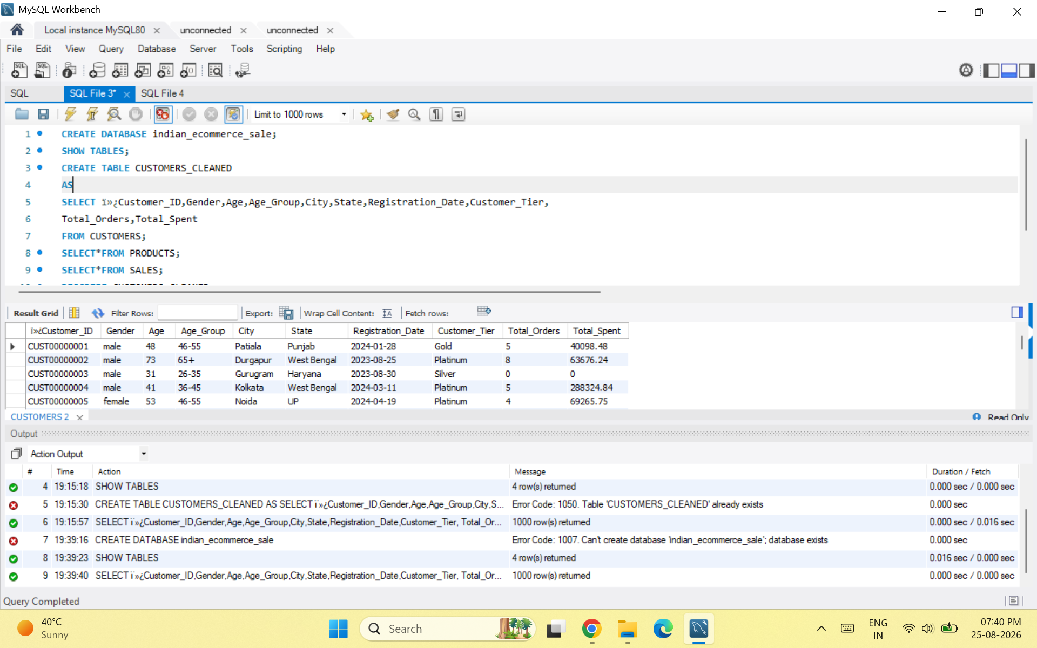
SCREENSHOT 2: BASIC_QUARIES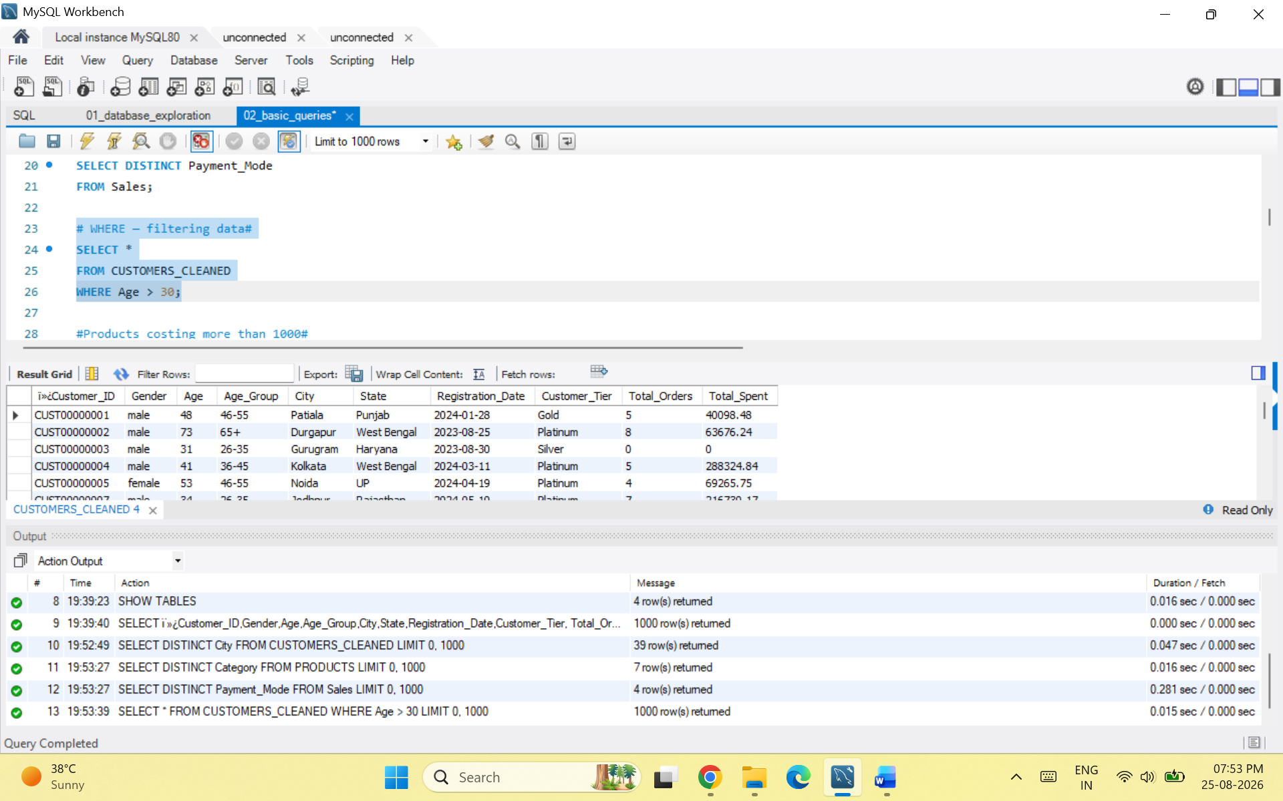

SCREENSHOT 3: MATHEMATEICAL FUNCTIONS
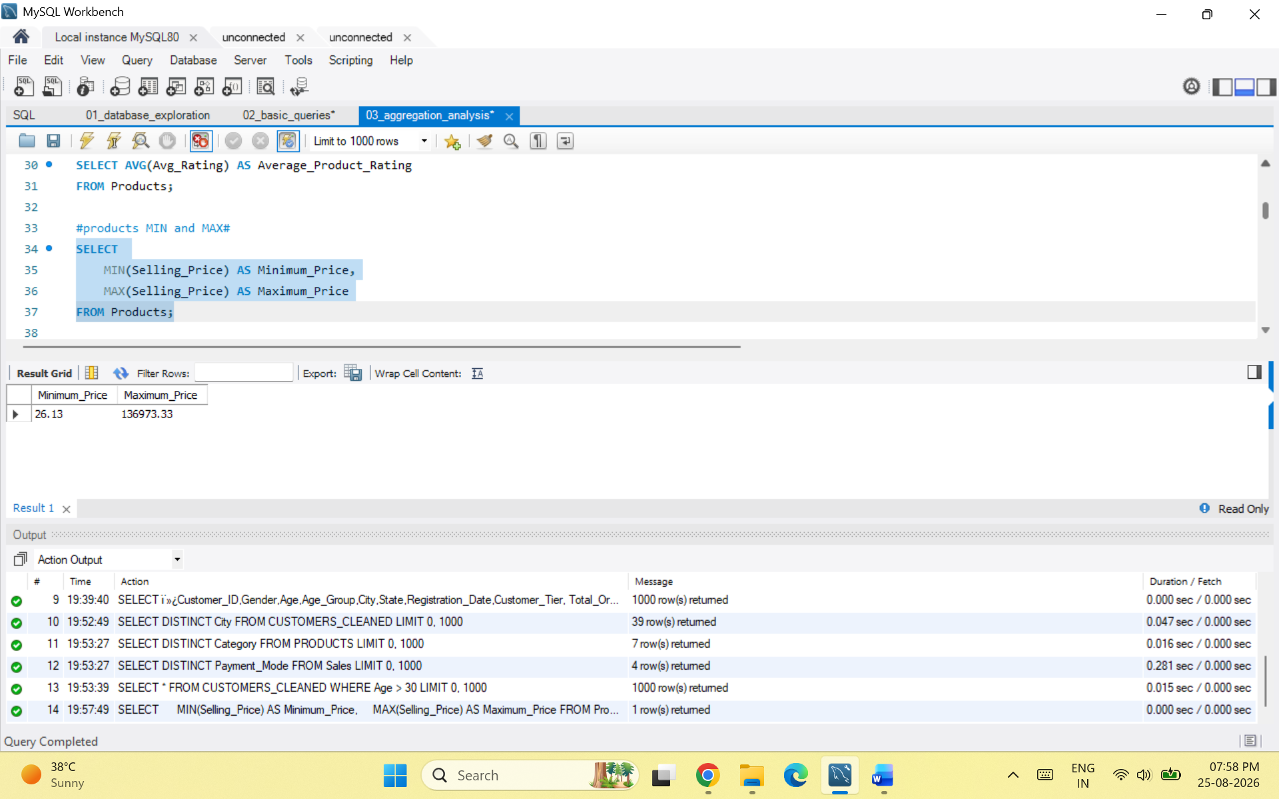
SCREENSHOT4: JOINS
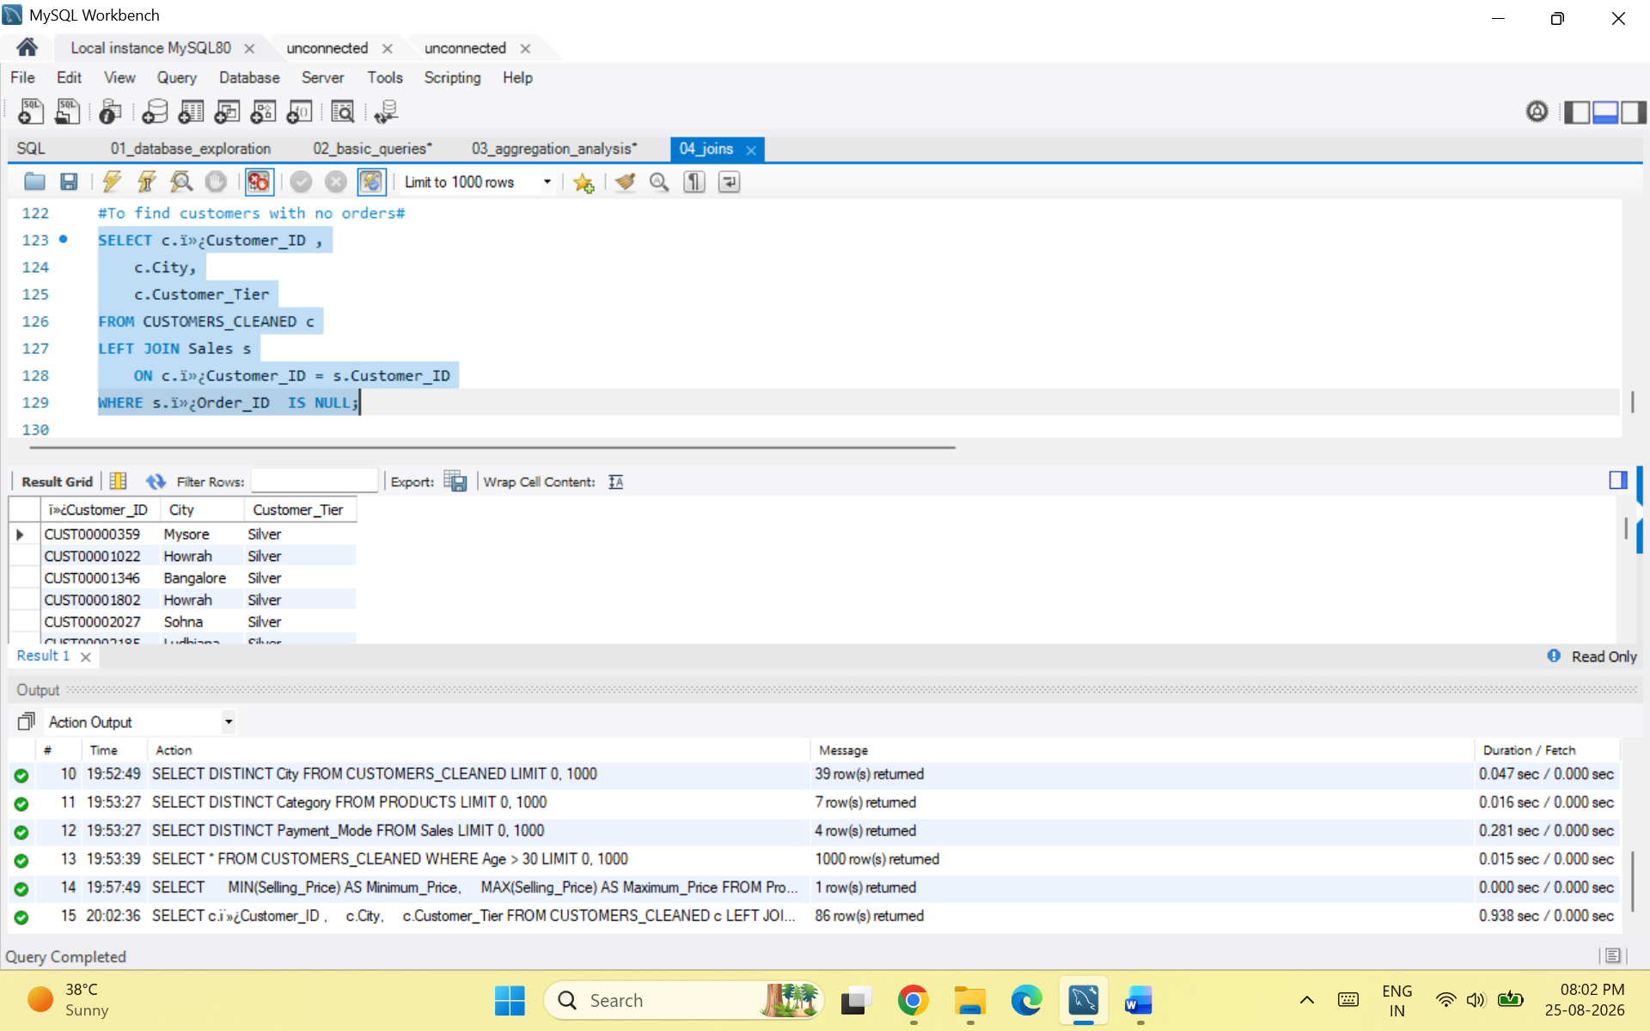
SCREENSHOT 4: PRODUCT_ANALYSIS
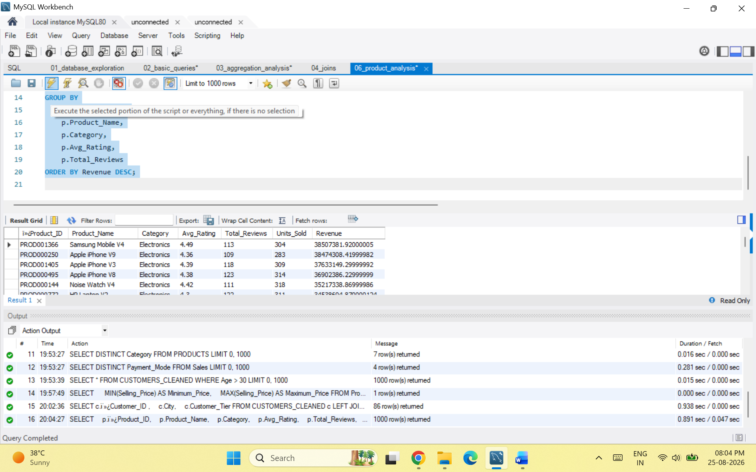

SCREENSHOT 5: DISCOUNT_ANALYSIS
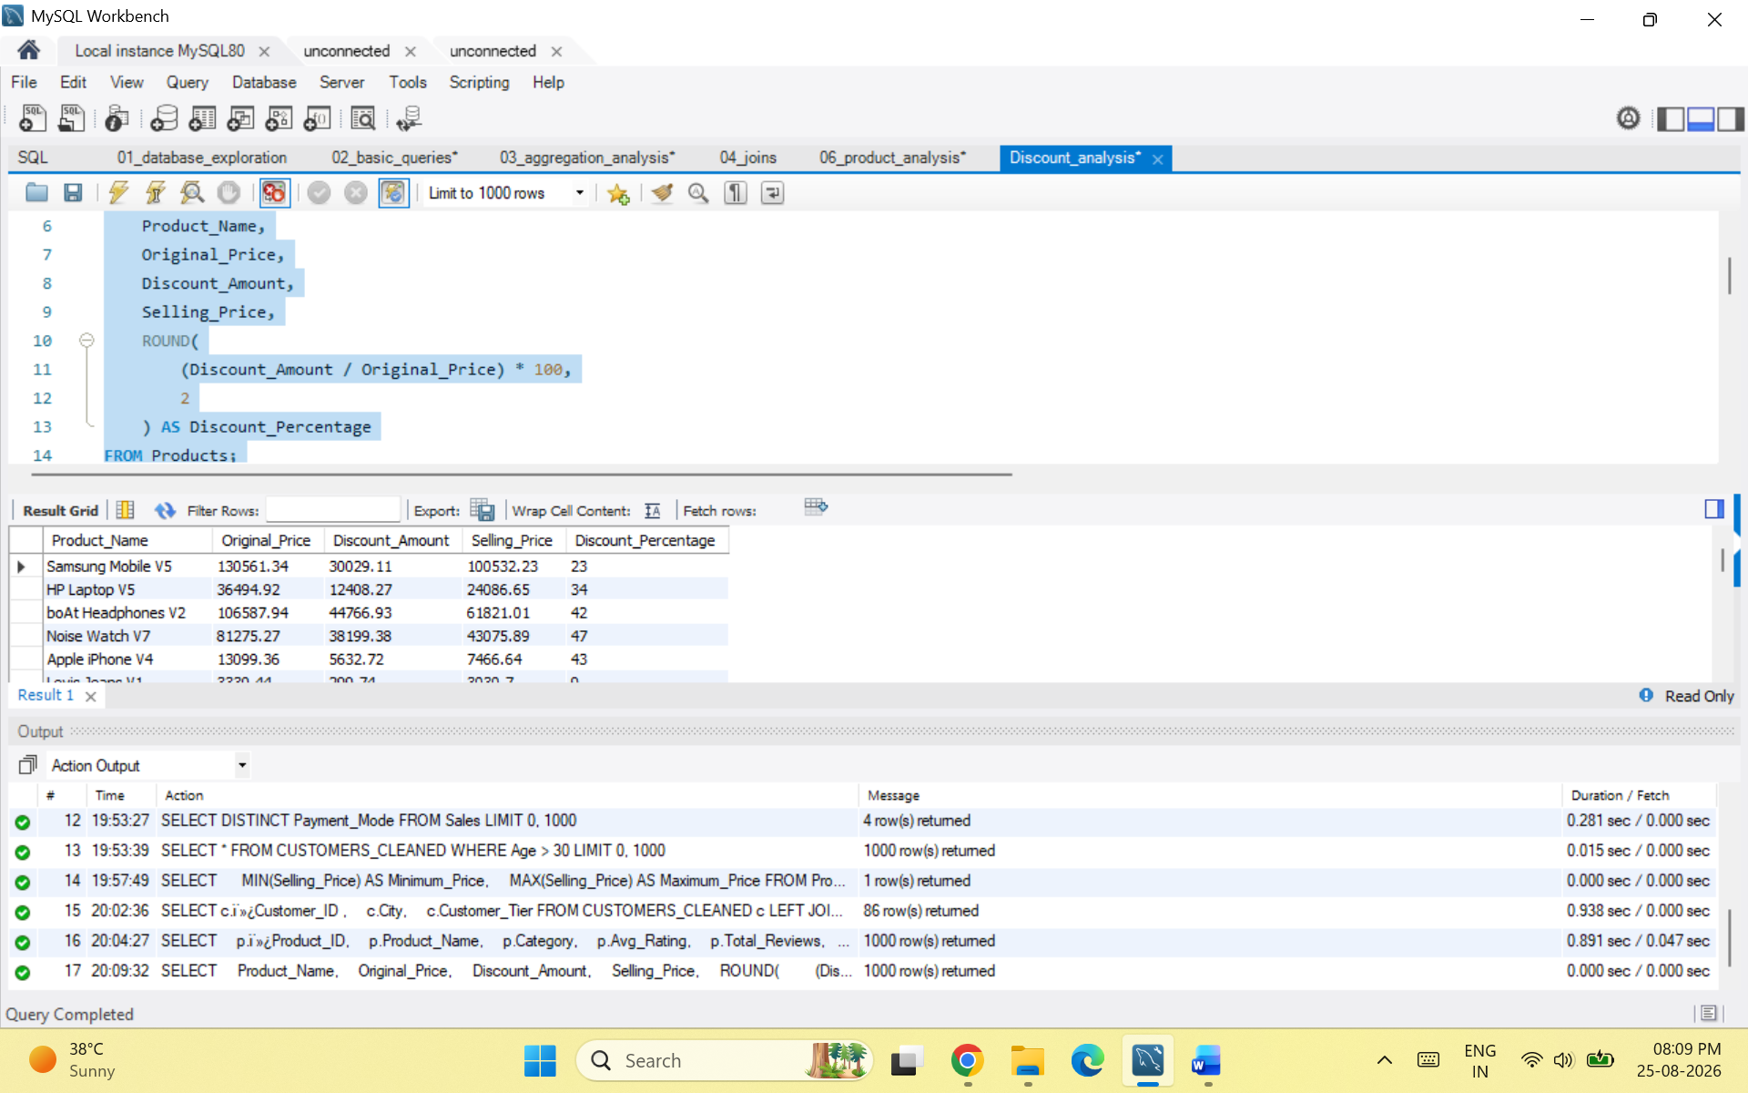

SCREENSHOT 6: COALESCE_ANALYSIS
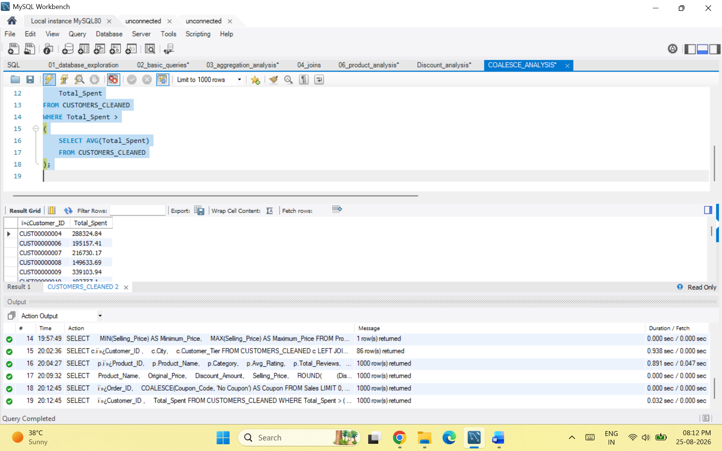

SCREENSHOT 7: ADVANCE_ANALYSIS
